**Github Repository Link**

[**https://github.com/Khush1351/Python-Practicals.git**](https://github.com/Khush1351/Python-Practicals.git)

1. Dictionary
2. Write a Python script to check whether a given key already exists in a dictionary.

**CODE:**

#a. Write a Python script to check whether a given key already exists in a dictionary.

#20CS007_Khush Bhalodiya

dict = {1:'Dog',2:'Lion',3:'Cat'} #Create a dictionary

print(1 in dict) #Checks and print whether 1 in present in dictionary or not

print('Tiger' in dict) #Checks and print whether 'Tiger' is present in dictionary or not

**OUTPUT:**

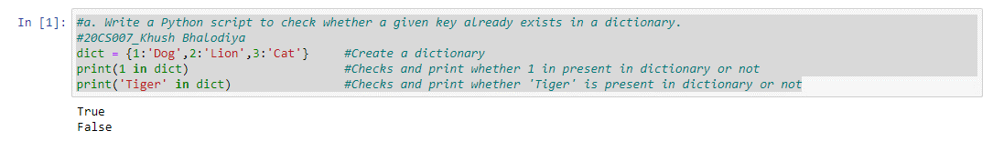

1. Write a Python script to merge two Python dictionaries.

**CODE:**

#b. Write a Python script to merge two Python dictionaries.

#20CS007_Khush Bhalodiya

dict1 = {1:20,2:30,3:40,4:50} #Create first dictionary

dict2 = {'Red':'Cherry','Orange':'Mango','Green':'Grapes'} #Create second dictionary

dict1.update(dict2) #Merges the two dictionary

print(dict1) #Prints the merged dictionary

**OUTPUT:**

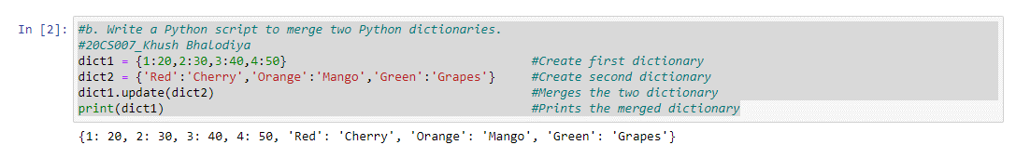

1. Write a Python program to sum all the items in a dictionary.

**CODE:**

#c. Write a Python program to sum all the items in a dictionary.

#20CS007_Khush Bhalodiya

dict = {'a':100,'b':300,'c':500} #Create a dictionary

print(sum(dict.values())) #Sums the values in dictionary and prints it

**OUTPUT:**

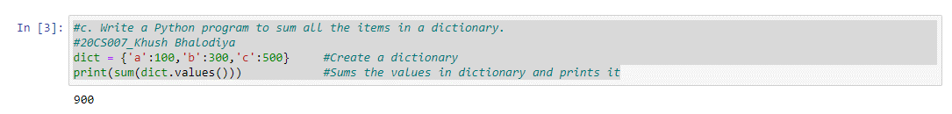

1. Write a Python script to add a key to a dictionary.

Sample Dictionary: {0: 10, 1: 20}

Expected Result: {0: 10, 1: 20, 2: 30}

**CODE:**

#d. Write a Python script to add a key to a dictionary.

#20CS007_Khush Bhalodiya

dict = {0: 10, 1: 20} #Create a dictionary

dict[2] = 30 #Add a key in dictionary

print(dict) #Prints the new dictionary

**OUTPUT:**

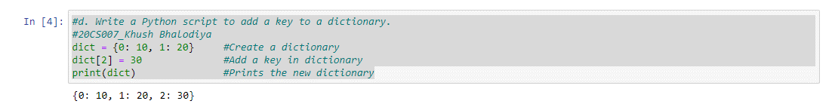

1. Write a Python script to concatenate following dictionaries to create a new one.

Sample Dictionary:

dic1= {1:10, 2:20}

dic2= {3:30, 4:40}

dic3= {5:50,6:60}

Expected Result: {1: 10, 2: 20, 3: 30, 4: 40, 5: 50, 6: 60}

**CODE:**

#e. Write a Python script to concatenate following dictionaries to create a new one.

#20CS007_Khush Bhalodiya

dic1={1:10, 2:20} #Create first dictionary

dic2={3:30, 4:40} #Create second dictionary

dic3={5:50, 6:60} #Create third dictionary

dic4 = {} #Create empty dictionary

for d in (dic1,dic2,dic3): #Concatenation of the three dictionary

dic4.update(d)

print(dic4) #Prints the concatenated dictionary

**OUTPUT:**

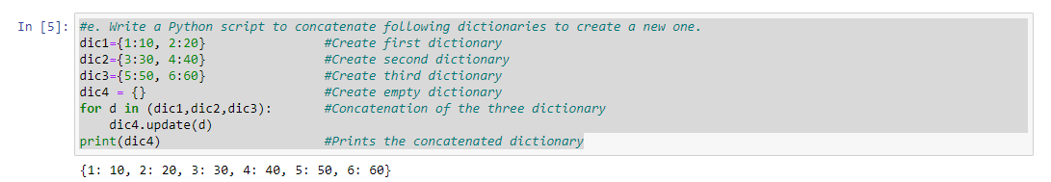

1. Tuple
2. Write a Python program to create a tuple with different data types.

**CODE:**

#a. Write a Python program to create a tuple with different data types.

#20CS007_Khush Bhalodiya

different_datatypes = (10,'Khush',3.56,True) #Creating a tuple with different data types.

print(different_datatypes) #Printing the Tuple

**OUTPUT:**

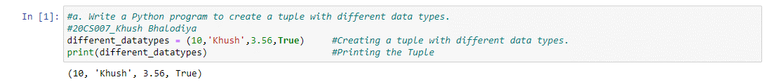

1. Write a Python program to create a tuple with numbers and print one item.

**CODE:**

#b. Write a Python program to create a tuple with numbers and print one item.

#20CS007_Khush Bhalodiya

numbers = (1,3,5,7,9,11,13) #Creating a tuple with numbers

print(numbers[2]) #Printing one item

**OUTPUT:**

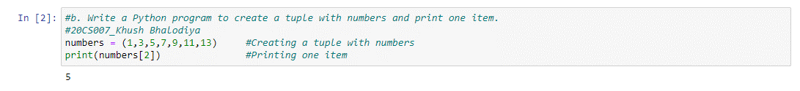

1. Write a Python program to add an item in a tuple.

**CODE:**

#c. Write a Python program to add an item in a tuple.

#20CS007_Khush Bhalodiya

fruits = ('Mango','Apple','Grapes') #Creating a tuple

print(fruits) #Printing the tuple

new_fruit = ('Lime',) #Declaring the item to be added

fruits = fruits + new_fruit #Adding an item to tuple

print(fruits) #Printing the new tuple

**OUTPUT:**

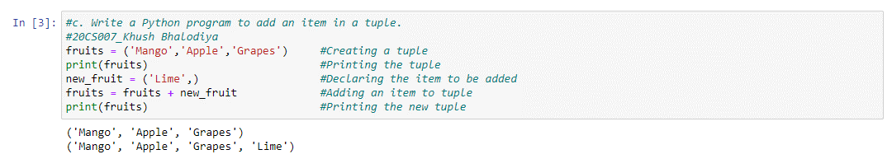

1. Write a Python program to convert a tuple to a string.

**CODE:**

#d. Write a Python program to convert a tuple to a string.

#20CS007_Khush Bhalodiya

tuple = ('K','H','U','S','H') #Creating the tuple

str = ''.join(tuple) #Converting the tuple to string

print(str) #Printing the string

**OUTPUT:**

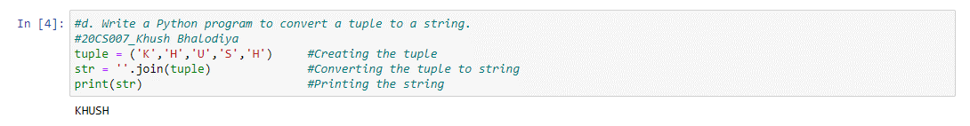

1. Write a Python program to find the length of a tuple.

**CODE:**

#e. Write a Python program to find the length of a tuple.

#20CS007_Khush Bhalodiya

fruits = ('Mango','Apple','Banana','Grapes') #Creating a tuple

print(len(fruits)) #Printing the length of tuple

**OUTPUT:**

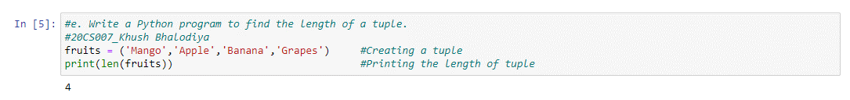

1. Set
2. Write a Python program to add member(s) in a set and clear a set.

**CODE:**

#a. Write a Python program to add member(s) in a set and clear a set.

#20CS007_Khush Bhalodiya

fruits = {'Mango','Banana','Apple'} #Creating a set

fruits.add('Lime') #Adding an item to set

print(fruits) #Prints the updated set

fruits.update(['Orange','Kiwi']) #Adding multiple items to the set

print(fruits) #Prints the updated set

fruits.clear() #Clear the set

print(fruits) #Prints the empty set

**OUTPUT:**

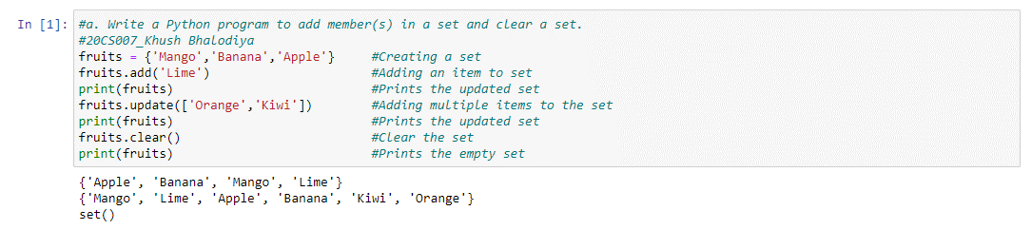

1. Write a Python program to remove an item from a set if it is present in the set.

**CODE:**

#b. Write a Python program to remove an item from a set if it is present in the set.

#20CS007_Khush Bhalodiya

fruits = {'Mango','Banana','Apple'} #Creating a set

fruits.remove('Mango') #Removing the item from the set

print(fruits) #Prints the new set

**OUTPUT:**

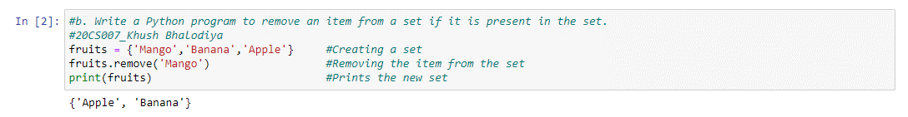

1. Write a Python program to create an intersection, Union, difference of sets.

**CODE:**

#c. Write a Python program to create an intersection, Union, difference of sets.

#20CS007_Khush Bhalodiya

fruits = {'Mango','Banana','Apple','Carrot'} #Create set 1 of fruits

vegetables = {'Cucumber','Tomato','Potato','Mango'} #Create set 2 of vegetables

inter = fruits.intersection(vegetables) #Finds the item common between the two set

union = fruits.union(vegetables) #Combines the two given set

dif1 = fruits.difference(vegetables) #Finds the item present in fruits set that are not present in vegetables set

dif2 = vegetables.difference(fruits) #Finds the item present in vegetables set that are not present in fruits set

print(inter) #Prints the intersection

print(union) #Prints the union of to set

print(dif1) #Prints difference

print(dif2) #Prints difference

**OUTPUT:**

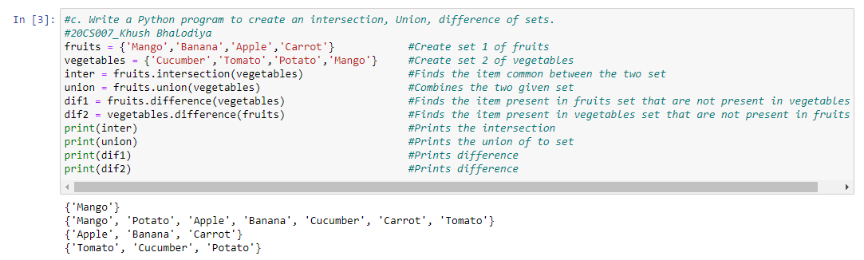

1. Write a Python program to find maximum and the minimum value in a set.

**CODE:**

#d. Write a Python program to find maximum and the minimum value in a set.

#20CS007_Khush Bhalodiya

number = {35,65,14,78,2,90,355} #Create a set of number

print(max(number)) #Finds and print the maximum value

print(min(number)) #Finds and print the minimum value

**OUTPUT:**

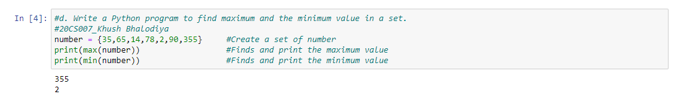

1. Write a Python program to find the most common elements and their counts from list, tuple, dictionary.

**CODE:**

#e. Write a Python program to find the most common elements and their counts from list, tuple, dictionary.

#20CS007_Khush Bhalodiya

def CountFrequency(my_list):

freq = {} #Creating an empty dictionary

for item in my_list:

if(item in freq):

freq[item] += 1

else:

freq[item] = 1

for key,value in freq.items():

print("% d : % d"%(key,value))

if __name__ == "__main__":

my_list = [1,1,1,5,5,3,1,3,3,1,4,4,4,2,2,2,2]

CountFrequency(my_list)

**OUTPUT:**

